18.5: Assume a room size of 20 ft X 20 ft X 20 ft

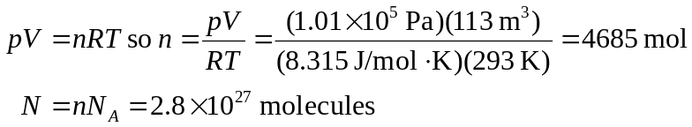
b) 